**Customer Segmentation :**

*‘Process of dividing a customer base into groups of individuals that are similar in specific ways relevant to marketing’ such as gender, age, interests, spending habits etc.*

Divison of potential customers in a given market to discrete **groups**

|

|

--------------------------------------------------------------------------------------------------------------------------

| |

**Needs**  **Buying Characteristics**

(i.e all the customers who wants a particualr product) (i.e response to messages, emails,

marketing channels , sales channels etc)

**General Process of segmentation :**

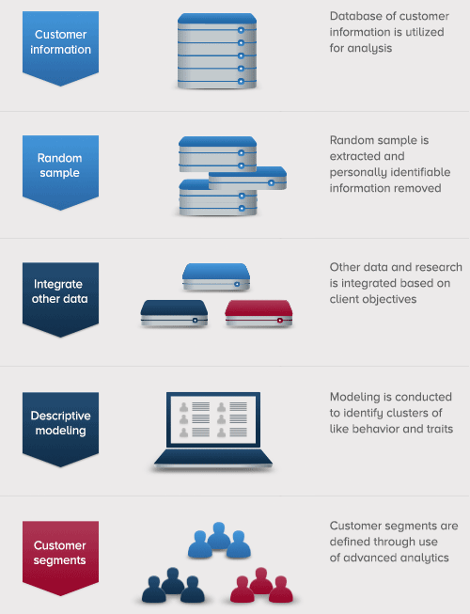

**Common Segmentations :**

1. Geographic segmentations ---> customers at a particular geo location may want a particular product.

Ex : People living in poles don’t need air coolers so no need to advertise these people for air coolers.

2. Demographics ---> Race, ethnicity, age, gender, religion, education, income, occupation, martial status etc…

3. Pyschographic ---> Lifestyle, values, social class, personality etc….

4. Behavioural ---> usage, loyality, awareness, occasions, knowledge, liking, purchase patterns etc….

**Advanced Segmentation :**

